Visual Basic Screenshots #11 – String Manipulation - Tom H

1. A text file is a sequential file that can be used to right text onto and even used to write code with. Text files end in ‘.txt’ and is either a notepad or notepad++ file.
2. A Stream Reader allows you to open any text file. It is an object available to System.IO.
3. 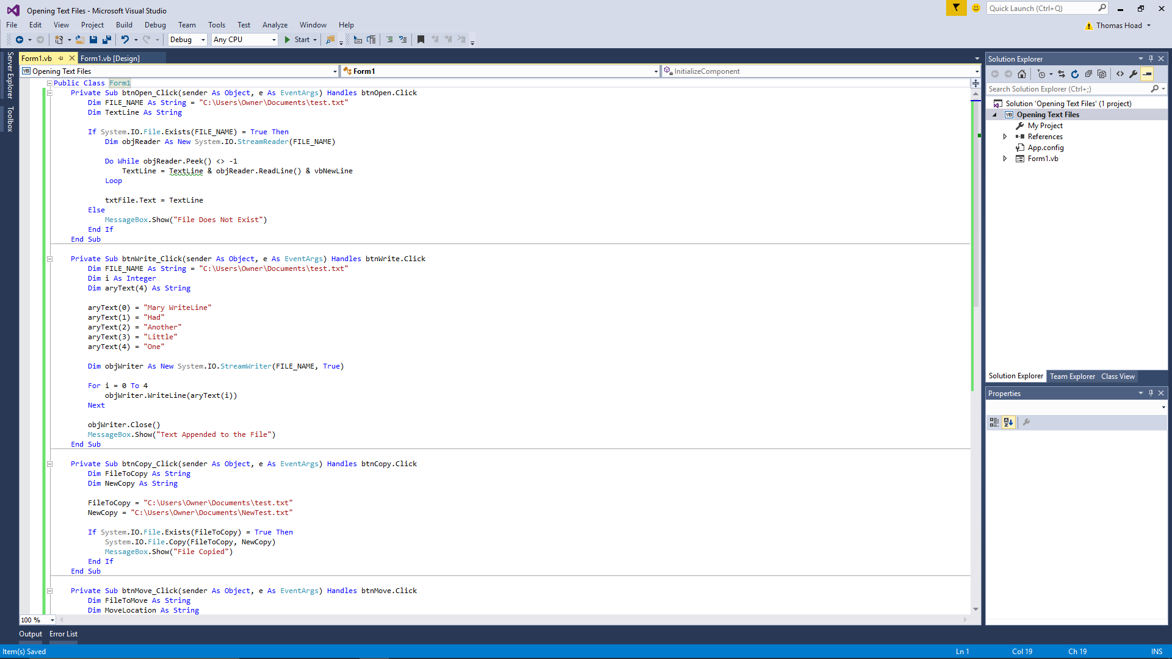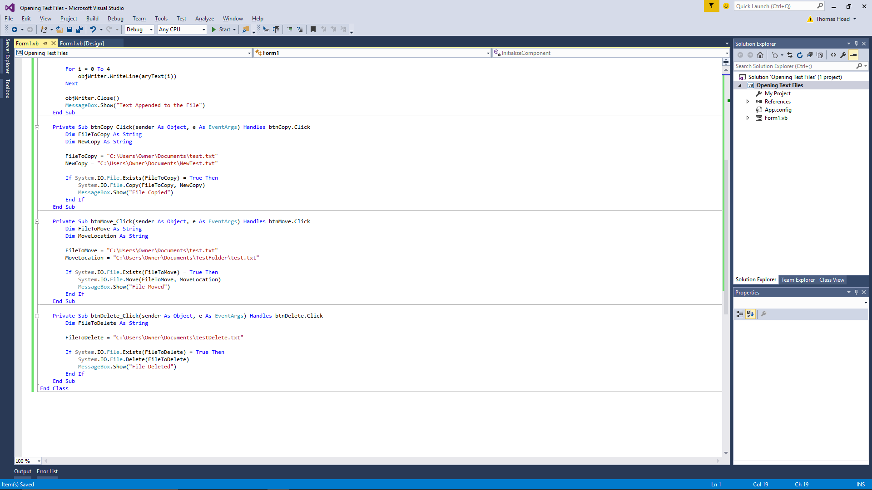If you want to create a file if one doesn't exist, the process is again quite simple: “Dim objWriter As New System.IO.StreamWriter (FILE_NAME, **False**)” This time, we've just added the word "False" to the end of FILE_NAME. This will ensure that a new text file is created if one doesn't exist.